ProjectDesignPhase-II

DataFlowDiagram&UserStories

|  |  |
| --- | --- |
| Date | 19October2022 |
| TeamID | PNT2022TMID23206 |
| ProjectName | VisualizingandPredictingHeartDiseaseswithanInteractiveDashBoard |
| MaximumMarks | 4Marks |

DataFlowDiagrams:

A Data Flow Diagram(DFD)isatraditionalvisualrepresentationof the informationflowswithina system.A neatand clearDFDcandepict the rightamount of the system requirement graphically. It shows howdata enters and leaves the system, what changes the information, and where data isstored.

DATAFLOWDIAGRAM:

START

Collectthedataset

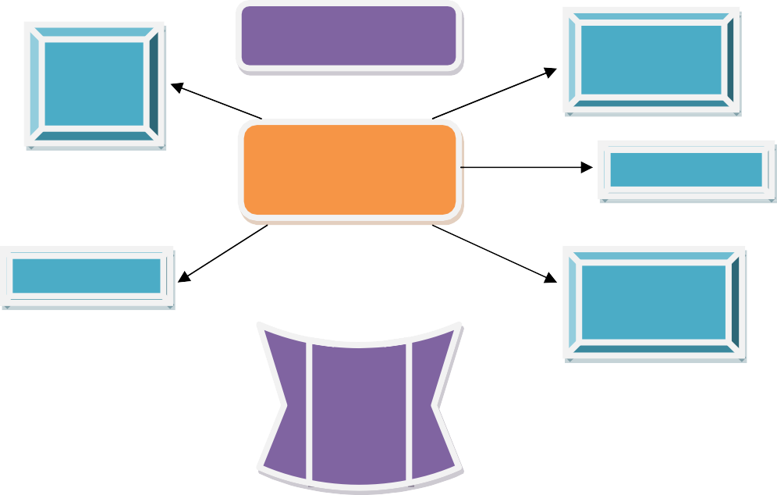

Apply the support vectormachinealgorithmtopredict

DataModule

**IBMCOGNOS** Story

Uploadthe

**dataset** Report

Exploration Dashboard

PYTHON

inmachinelearning

Disease

prediction

Yes

No

Patienthasheart

disease

Patientdoesnot

haveheartdisease

Usethebelowtemplatetolist alltheuserstoriesfortheproduct.

|  |  |  |  |  |  |  |
| --- | --- | --- | --- | --- | --- | --- |
| **UserType** | **Functional**  **Requirement(Epic)** | **User**  **StoryNumber** | **UserStory/Task** | **Acceptancecriteria** | **Priority** | **Release** |
| Customer(Mobileuser) | Registration | USN-1 | Asa user,Icanregister for theapplicationbyenteringmyemail,password, and confirming my password. | I can access myaccount/dashboard. | High | Sprint-1 |
|  |  | USN-2 | Asa user,IwillreceiveconfirmationemailonceI haveregisteredforthe application | Icanreceive  confirmationemail&click confirm. | High | Sprint-1 |
|  |  | USN-3 | Asa user,Icanregister fortheapplicationthroughFacebook | Icanregister&  access the dashboardwithFacebookLogin. | Low | Sprint-2 |
|  |  | USN-4 | Asauser, IcanregisterfortheapplicationthroughGmail | Icanregister&  accessthedashboardwith Gmail Login | Medium | Sprint-1 |
|  | Login | USN-5 | Asauser,Icanlogintotheapplicationbyenteringemail&password | I can register &accessthedashboard | High | Sprint-1 |

|  |  |  |  |  |  |  |
| --- | --- | --- | --- | --- | --- | --- |
| **UserType** | **Functional**  **Requirement(Epic)** | **User**  **StoryNumber** | **UserStory/Task** | **Acceptancecriteria** | **Priority** | **Release** |
|  |  |  |  | withGmail Login |  |  |
|  | Dashboard | USN-6 | Profile-view&updateyourprofile | Icanseetheprofile. | Medium | Sprint-2 |
|  |  | USN-7 | ChangePassword-usercanchangethepassword | Icanabletochangethe password. | High | Sprint-1 |
|  |  | USN-8 | Home-Analyzeyour Heart | Icandetect the health  conditionfromwhereever I want. | High | Sprint-1 |
|  |  | USN-9 | Theuser willhavetofillinthebelow13 fields for thesystemtopredicta disease  -AgeinYear  -Gender  -ChestPainType  -FastingBloodSugar  -RestingElectrographicResults(Restecg)  -ExerciseInducedAngina(Exang)  -TheslopeofthepeakexerciseSTsegment  -CA–Number ofmajorvesselscoloredbyfluoroscopy  -Thal  -TrestBloodPressure  -SerumCholesterol  -Maximumheart rateachieved(Thalach)  -STdepressioninducedbyexercise(Oldpeak) | These are thecategoriesavailableinthat application. | High | Sprint-2 |
|  |  | USN-10 | ViewDoctors-viewdoctor detailbysearchingbynames or filter byspecialty | Using thisapplication,people  canknownthatthespeciality doctors. | Medium | Sprint-1 |
| Customer(Webuser) | SystemRequirement | USN-11 | 1. HardwareRequirement    1. LaptoporPC       * I5processor systemorhigher       * 4GBRAM orhigher | These are all thespecificationavailablein your PC. | High | Sprint-2 |

|  |  |  |  |  |  |  |
| --- | --- | --- | --- | --- | --- | --- |
| **UserType** | **Functional**  **Requirement(Epic)** | **User**  **StoryNumber** | **UserStory/Task** | **Acceptancecriteria** | **Priority** | **Release** |
|  |  |  | * 128GBROMorhigher   ii. AndroidPhone(12.0 andabove) |  |  |  |
|  |  | USN-12 | 1. SoftwareRequirement    1. LaptoporPC       * Windows10orhigher       * AndroidStudio | Installyourapplication.  Thissystemcanbeused to predict thepresence of heartdisease. | Medium | Sprint-2 |
|  |  | USN-13 | ***Reference-https://ieeexplore.ieee.org/document/9619208/*** | GoandCheckourReference link. | Medium | Sprint-1 |
| CustomerCareExecutive | Dashboard | USN-14 | Query | You can post yourqueriesinthetextbox  availableinthatapplication. | High | Sprint-1 |
|  |  | USN-15 | TollFree | Askyourdoubts in  givennumber(8365492107). | High | Sprint-1 |
|  |  | USN-16 | Ratings | Giveyourratingsasyour wish. | Medium | Sprint-1 |
| Administrator | Dashboard | USN-17 | Verification | VerificationthroughCAPTCHA  VerificationthroughI’m not a robot | High | Sprint-1 |
|  |  | USN-18 | validation | Reconfirmingthenewpassword Sending atwo digit number in(Google account)your Old devices, so  thatyoucanenterinto | High | Sprint-2 |

|  |  |  |  |  |  |  |
| --- | --- | --- | --- | --- | --- | --- |
| **UserType** | **Functional**  **Requirement(Epic)** | **User**  **StoryNumber** | **UserStory/Task** | **Acceptancecriteria** | **Priority** | **Release** |
|  |  |  |  | a newdeviceBy  enteringthetwodigitnumber. |  |  |
|  |  | USN-19 | Feedback-sendfeedbacktotheAdmin. | Pleasesendyourfeedbackto host. | Medium | Sprint-2 |